PP-2021-3881/IRF21/2656

Ms Lisa Miscamble
General Manager
Wingecarribee Shire Council
PO Box 141
MOSS VALE NSW 277

Attention: Susan Stannard, Senior Strategic Planner

Dear Ms Miscamble

Planning proposal (PP-2021-3881) to amend Wingecarribee Local Environmental Plan 2010

I am writing in response to Council’s request for a Gateway determination under section 3.34(1) of the Environmental Planning and Assessment Act 1979 (the Act) in respect of the planning proposal to amend the Wingecarribee Local Environmental Plan 2010 to rezone and reduce the minimum lot size of land at 105 -119 Bong Bong Road, Mittagong (part Lot 115 DP 1067955).

As delegate of the Minister for Planning and Public Spaces, I have now determined that the planning proposal should proceed subject to the conditions in the enclosed Gateway determination.

I have also agreed, as delegate of the Secretary, the planning proposal’s inconsistencies with section 9.1 Directions 1.2 – Rural Zones, 1.5 – Rural Lands and 2.3 – Heritage Conservation are justified in accordance with the terms of the Direction. No further approval is required in relation to these Directions.

Council may still need to obtain the agreement of the Secretary to comply with the requirements of relevant section 9.1 Directions 4.4 – Planning for Bushfire Protection and 5.2 – Sydney Drinking Water Catchment. Council should ensure this occurs prior to public exhibition / the plan being made.

It is noted that Council has requested to be authorised as the local plan-making authority. I have considered the nature of Council’s planning proposal and have conditioned the Gateway for Council to be authorised as the local plan-making authority.

The amending local environmental plan (LEP) is to be finalised within 12 months of the date of the Gateway determination. Council should aim to commence the exhibition of the planning proposal as soon as possible. Council’s request to draft and finalise the LEP should be made directly to Parliamentary Counsel’s Office six weeks prior to the projected publication date. A copy of the request should be forwarded to the Department of Planning, Industry and Environment.

The state government is committed to reducing the time taken to complete LEPs by tailoring the steps in the process to the complexity of the proposal, and by providing clear and publicly available justification for each plan at an early stage. In order to meet these commitments, the Minister may take action under section 3.32(2)(d) of the Act if the time frames outlined in this determination are not met.

Should you have any enquiries about this matter, I have arranged for Mr Andrew Hartcher, Senior Planner, to assist you. Mr Hartcher can be contacted on 4247 1823.

Yours sincerely

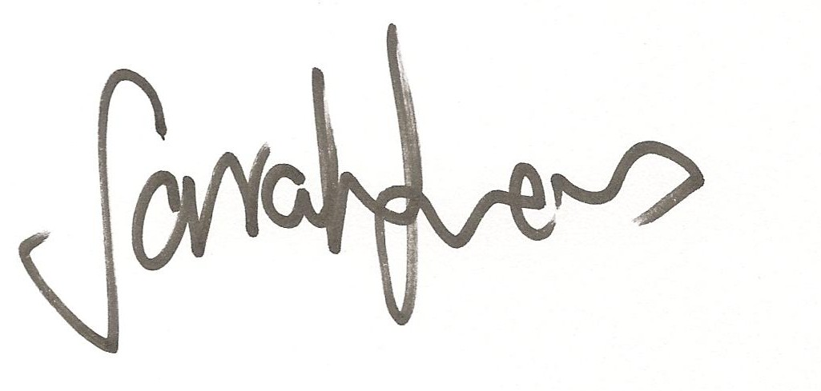

2 July 2021

Sarah Lees
Director, Southern Region
Local and Regional Planning

Encl: Gateway determination
Authorised plan-making reporting template

